District Commissioner
Potteries North
Vacancy Pack and Role Description

Potteries North District

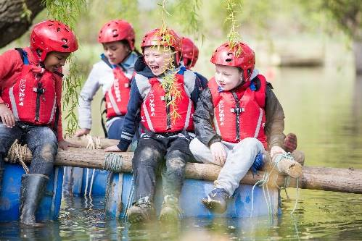
About Us

Potteries North District is a Scout District operating within Staffordshire Scout County with over 948 young members and 329 adult leaders. They operate in the Potteries and beyond supporting the delivery of scouting across 14 Groups, including Squirrels and Explorer Scouts.

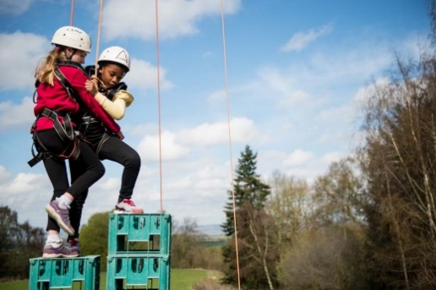
Supporting Adventure

Potteries North District are responsible for supporting the delivery of active and adventurous programmes for all sections.

In all sections the focus is on the delivery of a balanced yet exciting programme with a focus on developing skills for life through outdoor activities and adventure.

Youth Focus

Through our Youth Shaped initiative, we reflect the fact that Scouting is a Youth Organisation led by young people and supported by adults. Young people are at the heart of our decision making with respect to programme, events and competitions and influence our development strategies, local objectives, priorities, and governance.

Development

Scouting is a growing movement and Potteries North District has potential for good growth of both youth Members and Adult volunteers. Supporting growth and development is important to ensure that we can accommodate the growing number of young people who wish to join the world’s largest and most successful youth movement. This means recruiting more adults and opening new provision to meet demand.

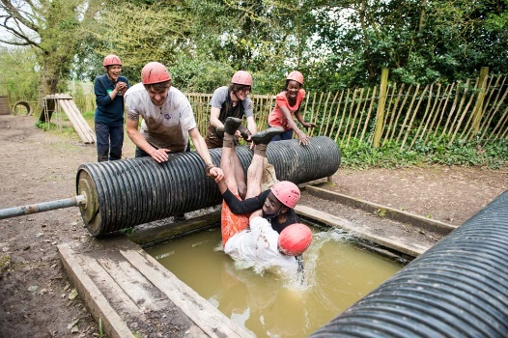

Find out more

To find out more about us please visit our website at

www.staffordshirescouts.org.uk

Thank you for considering the role of District Commissioner or nominating someone you think would be good for the role, it will make a huge difference to Moorlands District.

ROLE
DESCRIPTION
This vacancy is for a District Commissioner of Potteries North District, At the 2022 membership census they had over 948 youth members between the ages of 4 and 18 involved in our, Squirrel, Beaver, Cub, Scout, Explorer and Young Leader sections. They have over 329 adult volunteers, who undertake roles including working directly with young people, adults who manage and support other adults, adults who are experts in programme and activity areas and adults who support elements of the programme
The District Commissioner will be the lead volunteer in the District. The District Commissioner will be supported by the County Commissioner, and the Regional Support Team.
A full and comprehensive induction, as well as ongoing support will be provided to the successful candidate, which will include the opportunity to visit UK HQ, Gilwell Park, to meet with key staff and volunteer.
Purpose of the Role
You will be required to:
- Lead and manage the Scout District.
- Ensure that the District provides good quality Scouting for young people.
- Develop Scouting in the District.
- Promote and maintain the policies of the Association within the District, with a specific focus on safety, safeguarding and governance.
- Proactively manage adults in the District.
Responsible to:
County Commissioner
Responsible for:
Group Scout Leaders, District Youth Commissioner, District Explorer Scout Commissioner, District Scout Network Commissioner, Deputy District Commissioner(s) (where appointed), Assistant District Commissioners, District Scouters, District Advisers.
Main Contacts:
Deputy District Commissioner(s), Assistant District Commissioners, District Chairman, District Explorer Scout Commissioner, District Scout Network Commissioner, members of the County Executive Committee and its sub-committees, other District Commissioners in the County. Members of the local community, schools and other youth organisations.

Appointment requirements:
The completion of a Wood Badge relevant to the District Commissioner appointment.
Main Responsibilities
Note that some of the tasks for which the District Commissioner is responsible may be delegated to others in the District and a role share is possible.
Tasks may be delegated to Deputy District Commissioners (if appointed) and Assistant District Commissioners.
The following are the main tasks for which the District Commissioner is accountable:
- Producing a vision for the District and implementing a development plan to meet that vision.
- Ensuring that the Scout District thrives and has in place the best systems possible to support Scout Groups and Explorer Scout Units and all adults working in the District.
- Ensuring that Scouting in the District is attractive to young people and adults from all backgrounds
- Ensuring that the District has an adequate team of supported and appropriate adults working effectively together and with others to meet the Scouting needs of the area.
- Ensuring that problems within the District are resolved so that excellent Scouting is provided to young people in the District.
- Working with the County Commissioner and other District Commissioners in the County to share ideas and implement best practice initiatives to support Scouting in the County.

Core Tasks
The role of District Commissioner has several functions relating to six key areas of management and leadership.
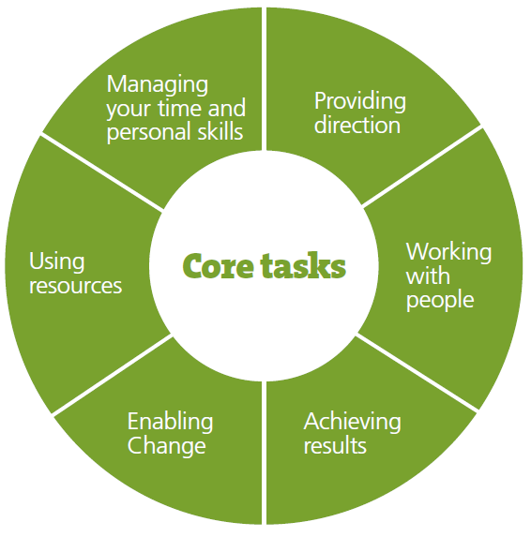

Providing Direction
As an effective District Commissioner, you will be required to:
- Lead by example to promote a co-operative culture of working in the District.
- Create a vision for the future development of the District.
- Take into account the local environment and the strategic plan of The Scout Association and your County, develop a plan for the District and work with others to implement and review it.
- Provide leadership, inspiration and motivation for all Leaders and Commissioners working in the District.
- Ensure that everyone in the District follows the policies and rules of The Scout Association.
- Carry out regular one-on-one meetings with members of your team.
Working With People
As an effective District Commissioner you will be required to:
- Develop good working relationships, based on trust and Scout Values, with the adults within the District and with others.
- Identify the roles that you need to make the District work effectively and recruit suitable people into those roles.
- Allocate tasks to people within the District team and monitor their progress.
- Support adults in the District team to develop by completing formal training requirements, learning on the job, trying out new skills and addressing problems affecting performance.
- Build a team spirit in the District and support the development of the team as a whole.
- Address conflict as it occurs within the District and reduce the likelihood of conflict through good communication and other methods.
- Run effective team meetings in the District and participate fully in the District Executive and County meetings.
- Ensure that adults in the District keep to the standards of performance required and that the correct procedures are followed in consultation with the County Commissioner if serious problems occur.
- Carry out effective reviews and re-assign or retire people if necessary
- Build and maintain collaborative relationships with other, relevant organisations in your District's local area and other Scout Districts.
Achieving Results
As an effective District Commissioner you will be required to:
- Satisfactorily complete projects in the District for which you are responsible.
- Ensure that all the initiatives in the District are managed carefully.
- Ensure that there are suitable processes in place within the District to ensure that Scouting is effectively delivered to young people.
- Work with the District Executive Committee and the District Team to ensure that Scouting is promoted locally.
- Build up an understanding of the young people in your local area and ensure that Scouting is promoted effectively to them including a focus on their needs and expectations.
- Monitor and review the progress that GSLs, District Explorer Scouts and the Scout Network are making against their targets and plans.
- Continually improve the performance of all elements of Scouting within the District.
- Have a robust District Development plan in place and regularly review progress.
Enabling Change
As an effective District Commissioner you will be required to:
- Support and encourage adults in the District to think of new and creative ways to improve Groups, Explorer Scout Units and the Scout Network.
- Communicate your vision for the future of the District and lead people through changes that this vision requires.
- Develop effective plans to implement change and then carry them out, working together with relevant members of the District.
- Recognise the contribution of others towards change and improvement.
Managing your Time and Personal Skills
As an effective District Commissioner you will be required to:
- Prioritise the responsibilities of District Commissioner
- Agree realistic goals and targets with your County Commissioner for the development of the District that work towards The Scout Association’s strategic objectives
- Consider the future requirements of your role then identify, plan and address areas for personal development
- Ask for and act on feedback about how you carry out your role
- Develop and maintain personal contacts with people both inside and outside of Scouting who may be able to help you to achieve your plans for the District
- Attend National, Regional or County District Commissioner meetings/days/workshops.
Person Specification
Knowledge and Experience
Essential
- Experience of managing adults.
Desirable
- Understanding of the challenges of working in the voluntary sector.
- Experience of youth and/or community work with adult groups.
- Recent experience of working in the Scout or Guide Movement as an adult.
Skills
Essential
- Motivate the team by being a great listener and communicator.
- Provide strategic direction for the District.
- Provide inspirational leadership for the District.
- Build, maintain and facilitate effective working relationships with a wide range of people.
- Enable others to identify issues, develop attainable objectives and gain the necessary skills and confidence to work as an effective team.
- Negotiate compromises.
- Plan, manage and monitor own tasks and time.
- Ability to use basic computer software.
Desirable
Construct and implement long-term plans for development activities and be able to identify training, resourcing, and other needs as necessary.
Aim, Values and Method
Essential
- An understanding of the needs of volunteers.
- Flexible approach.
- Self-motivated.
- Able to work as part of a team and promote good teamwork.
- Resourceful, energetic and enthusiastic about the job.
- Acceptance of the Aims and Methods of the Scout Movement.

Nomination form for District Commissioner, Potteries North District
If you think you know just the right person for this role, or are interested in the role yourself, please complete the nomination form below, it should then be sent to Elizabeth Birch via:
- E-mail Elizabeth.Birch@staffordshirescouts.org.uk

Closing date 21st October 2022

Name of person you are nominating
Their address
Their telephone number
Their e-mail address
Their Scout Association membership number
(if appropriate and known)
Please explain why this person is suitable for this role, including relevant professional and voluntary experience from inside or outside Scouting (refer to role description).
Please describe the relevant skills that this person has for the role (refer to role description).
Please outline why you felt motivated to complete the nomination/self-nomination.
Your name:
Your telephone number:
Your e-mail address:

